Lab 06 Instructions
Marking Scheme:
All IP addresses are shown in the Packet Tracer Instruction Window
Task 0
- Open the Lab06 PT activity
- Enter your Name and E-Mail in Packet Tracer as shown below. The User Profile screen can be found under the Options/User Profile option. You will automatically receive a grade of 0 if you do not change the User Profile field values!
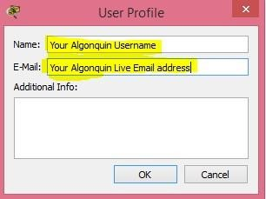
- Locate the Activity Instruction Window and take a screen capture of the IP addresses you’ve been assigned. Save this as task0_ip.jpg
Task 1
- Cable the network (remember Packet Tracer devices are not AutoMDIx)
- Connect the PC interface FastEthernet0 to Router0 interface FastEthernet0/0
- Connect Router0 interface FastEthernet0/1 to Router1 interface FastEthernet0/1
- Connect Router1 interface FasterEthernet0/0 to the Server Interface FastEthernet0
All link lights should turn green, and your PT completion should now be 6/24 as shown in the PT activity windows below.
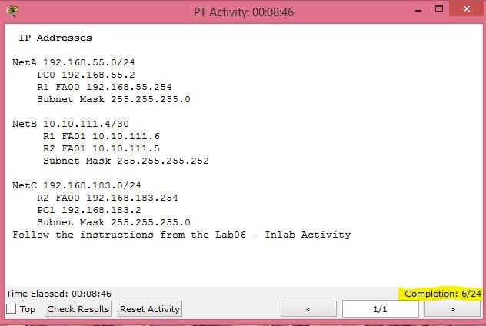

Your addresses may be

different. Use the addresses

from the PT Activity window,

not these.

- Configure the PC‘s IP (refer to the screen below to see how to access the PC’s IP configuration. Note that your assigned IP addresses appear in your PT Activity window.)
  - Set the PC to use Static Addressing
  - Assign the IP Address
  - Assign the Mask
  - Assign the Default Gateway
your PT completion should now be 9/24
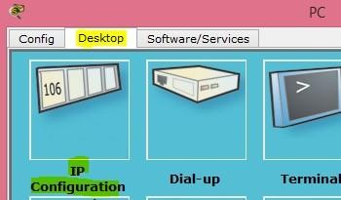
- To configure IP addresses on a router you must do it on each interface individually. First, click on the router you wish to configure. You should see a window popup. In that window click on the Interface you want to configure and then enter the IP address and subnet mask. When you have completed configuring the interfaces you can then close the window
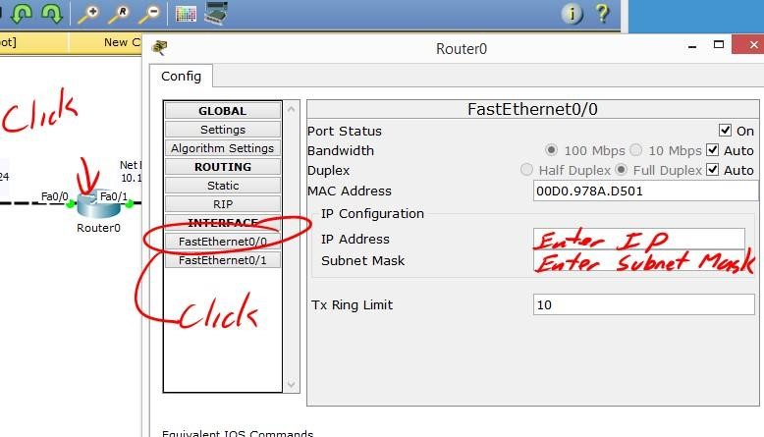
- Configure Router0
  - Assign the IP address to FastEthernet0/0
  - Assign the NetA subnet mask to FastEthernet0/0
  - Assign the IP address to FastEthernet0/1
  - Assign the NetB subnet mask to FastEthernet0/1
your PT completion should now be 13/24
- Configure Router1
  - Assign the IP address to FastEthernet0/0
  - Assign the NetC subnet mask to FastEthernet0/0
  - Assign the IP address to FastEthernet0/1
  - Assign the NetB subnet mask to FastEthernet0/1
your PT completion should now be 17/24
- Configure the Server
  - Set the Server to use Static addressing
  - Assign the IP Address
  - Assign the Mask
  - Assign the Default Gateway
your PT completion should now be 20/24

Task 2 Configure routing and testing
- The screen below illustrates how you add a static route to the routers in your PT topology.
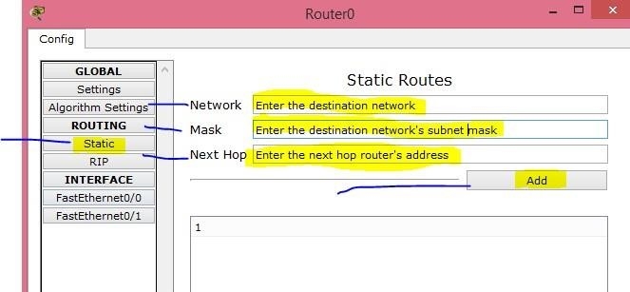
10.10.95.6
255.255.255.0
192.168.133.0
- Assign the correct static route to Router0 so that traffic from NetA can reach NetC
- Assign the correct static route to Router1 so that traffic from NetC can reach NetA
- Test the network to be sure the PC can reach the server. If it can’t, fix the problem and try again your PT completion should now be 24/24
- Save your PT file.
Demo this task and show your ping result from PC to Server to your lab instructor.
Follow the steps in the tasks below. Write the answers to the questions in the provided separate answers file.
Task 3 IP and ICMP (Questions 1 mark each)
- Open the Desktop command prompt on the PC and ping the server. This ping is used to populate the ARP tables. Note that the first Ping request may timeout.
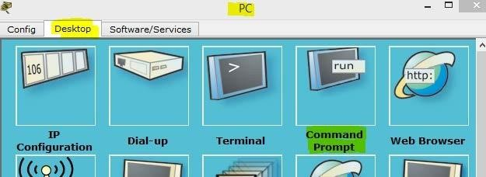
- Switch the Packet tracer to Simulation Mode (shown below). Make sure the Event List Filters include only ICMP and UDP as shown in the second screen below.
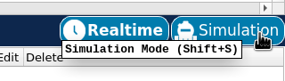
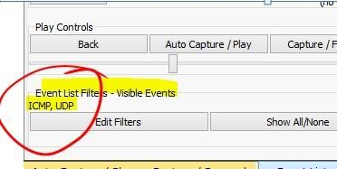

- Go back to real mode. Open the Desktop command prompt on the PC and ping the server again. Use the capture forward button (see screen below) to move the packet to Router0. Click on the PDU and then the inbound PDU details tab (see the second screen below).
  - What is the value of the TTL field in the IP Header?
  - What are the values of the Type and Code fields in the ICMP header
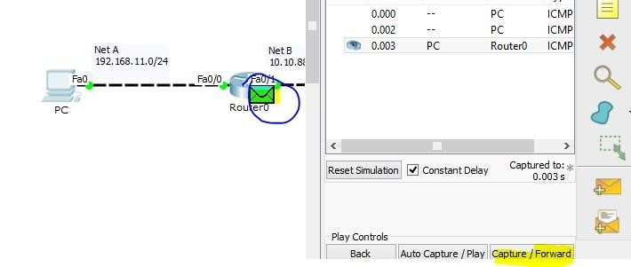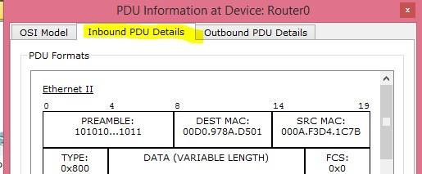
- Look at the Outbound PDU details tab and see if any of the values recorded in the above step have changed? What field and value (if any) changed?
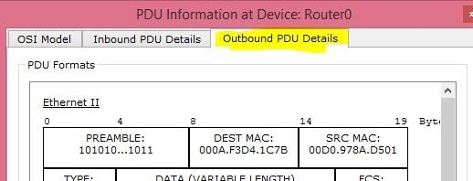
- Close the PDU information window. Use the capture forward button to move the PDU to the Server and back to Router0 . Click on the PDU and then the inbound PDU details tab.
  - What is the value of the TTL field in the IP Header?
  - What are the values of the Type and Code fields in the ICMP header
- What’s different between the Inbound and outbound PDUs?
- What’s different in the ICMP header between this PDU and the one you observed in Step 4

Task 4 Complex PDUs (Questions 1 mark each)
- In this task you need to build a series of “Complex PDUs” and use them to observe the behavior of the network. Make sure you are still in Simulation Mode. Reset the simulation
- Click on the Complex PDU icon and then click on the PC. A “Create Complex PDU” window like the second windows below should open 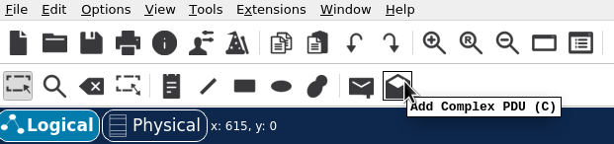

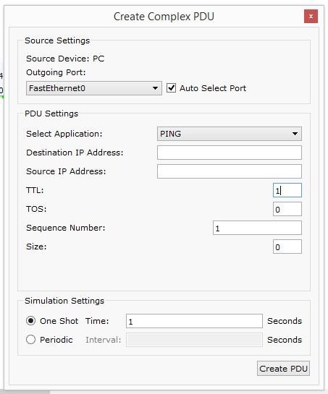
- Create the PDU with the following parameters
    - Select Application “Ping”
    - Destination IP Address: “the Server IP”
    - Source IP Address: “the PC IP”
    - TTL: “1”
    - Sequence number: “1”
    - Select “One Shot” with a Time value of “1”
    - Click Create PDU
- Use the “Capture/Forward” button to move the PDU to Router0. When the PDU reaches Router0 a second PDU should be created.
- Examine this PDU (outbound PDU details) and record the following:
    - Source IP
    - Destination IP
    - ICMP Type: and Code:
    - What comes after (below) the ICMP header? Describe what it is. Hint: examine the inbound PDU at Router0
- In Packet Tracer locate the Scenario list (bottom center of the screen) and click New to create a new scenario
- Create another complex PDU like the one above except this time set the TTL value to 2.
- Use the capture forward button to see how far the PDU will travel
    - What was the final device for the PDU, and how far will it travel? (a new PDU will be created at the final device) - ROUTER 0
    - In the new PDU that was generated, what are the source and destination IPs? – 192.168.104.254
192.168.104.2
- Create a new scenario and a new Complex PDU (from PC) with the following parameters
  - Select the Application “Ping”
  - Destination IP Address: “205.211.22.33”
  - Source IP Address: “the PC IP”
  - TTL: “32”
  - Sequence number: “2”
  - Select “One Shot” with a Time value of “1”
  - Click Create PDU
- Using Capture/forward advance the PDU until a return PDU is generated. Examine this returned PDU
- How far does the PDU travel? - ROUTER 0
- What are the ICMP type and code values of the returned PDU?
-0x08 & 0x00

- What meaning does the ICMP packet have? Hint: Refer to Lab 02 reference documents.
IT IS PROTOCOL
- Create a new scenario and a new Complex PDU (from PC) with the following parameters
  - Select Application “TFTP”
  - Destination IP Address: “the Server IP”
  - Source IP Address: “the PC IP”
  - TTL: “32”
  - Starting Source Port: “1025”
  - Select “One Shot” with a Time value of “1”
  - Click Create PDU
- Use the Capture/Forward button to move the PDU to the server
a. What type of PDU is moving towards the Server (look in the Event List?
UDP
- At the Server a new PDU will be created.
  - What type is it? ICMP
  - What are the ICMP type and code values of the returned PDU?
  - What meaning does the ICMP type and code have? (refer to the ICMP documentation from lab 2) Inform error message

Task 5 – Clean up and submission
- Save your Packet tracer file and upload it to the Lab 06 drop box
- Complete the answers file and upload it to the Lab 06 drop box
- Have the screenshot uploaded to the Lab 06 drop box

